## L16 HW –Inbound Link Focus

## Professor Navarro

# COP3834 – Web Application Development

# By Dylan Gartin

# Web Application Development(FA 2021_COP3834C.01 I&T)

### 10/23/2021

### **Background**

In the early days of SEO, web ranking was heavily influenced by keyword usage within a page’s content. The approach was simply the more keyword phrases used on a webpage, the more likely that was what the page was about.

Designers and marketers took advantage of this system and leveraged extreme amounts of keywords, known as keyword stuffing. Most search engines are now savvy enough to recognize this approach and will actually negatively rank a site that appears to be stuffing keywords.

Google and other search providers began using links between webpages as a ranking factor, known as PageRank. PageRank works by counting the number of quality links to a page to determine how important the page or content is to other sites. The more links, or back links, from quality sites, the better your page will rank (within the limitations of this part of the search algorithm).

Google ranks “follow” type links from high quality sources the most, followed by internal links (think navigation bar) and “nofollow” links from other sites. Add the Chrome extension “NoFollow Simple” to your browser to determine if a page is using “nofollow” links. They will be outlined in red.

In this assignment, you will create an additional page on your Top Rank SEO site, measure your external links and improve your site and page ranking by increasing your presence on the web.

### **Procedure**

1. Create at least 1 additional web page on your Top Rank SEO site. This can be an about-us, contact-us, air-news, blog, product info, or anything else to Improve the Internal linking structure on your site. As a team, It Is up to you how that work gets distributed. The page should match the current theme of the site in style. Submit screenshot of new web page in word or pdf document.

# All of our current webpages!

## Main Page

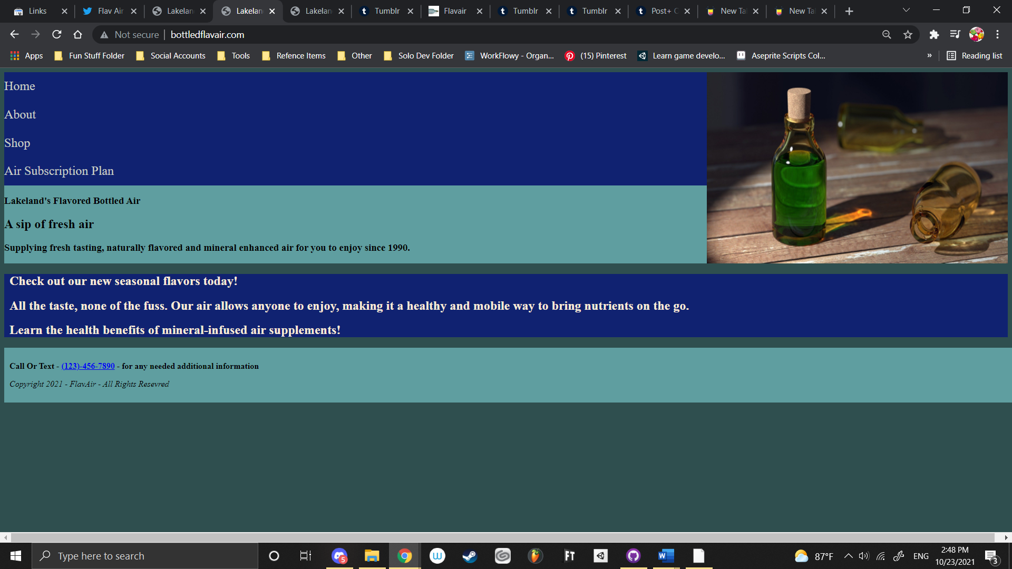

## About Page

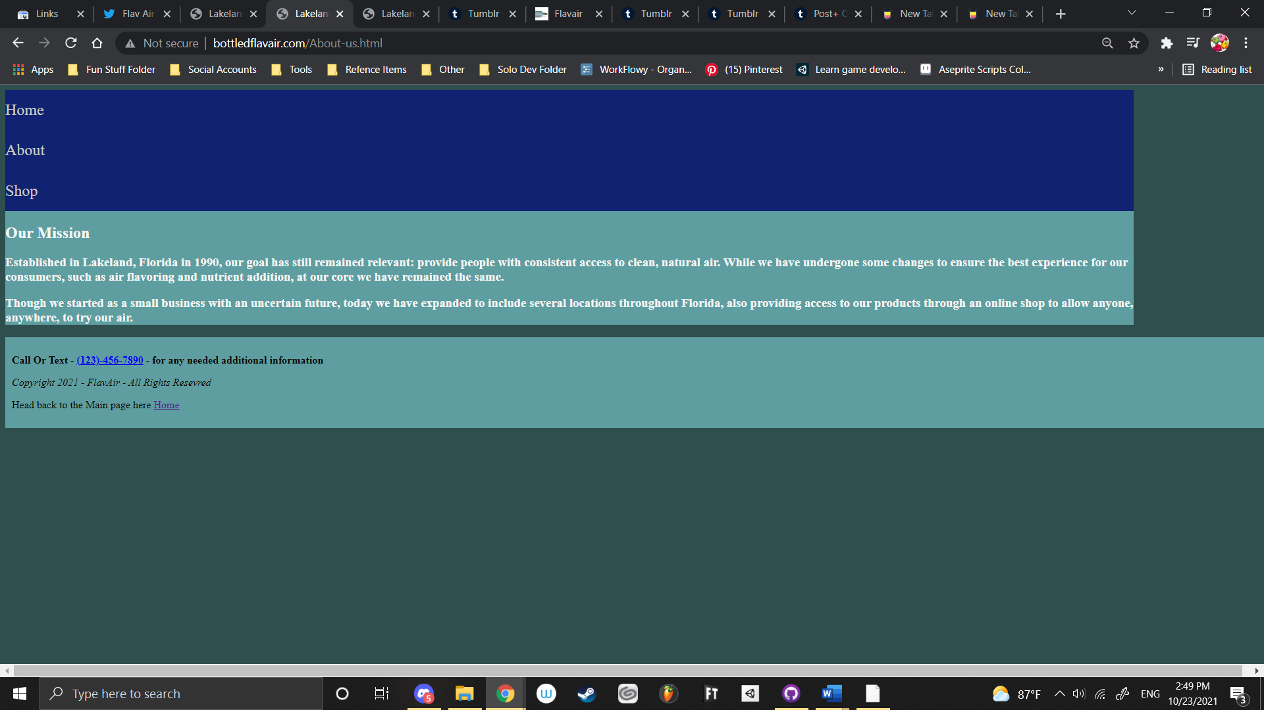

## Template product page

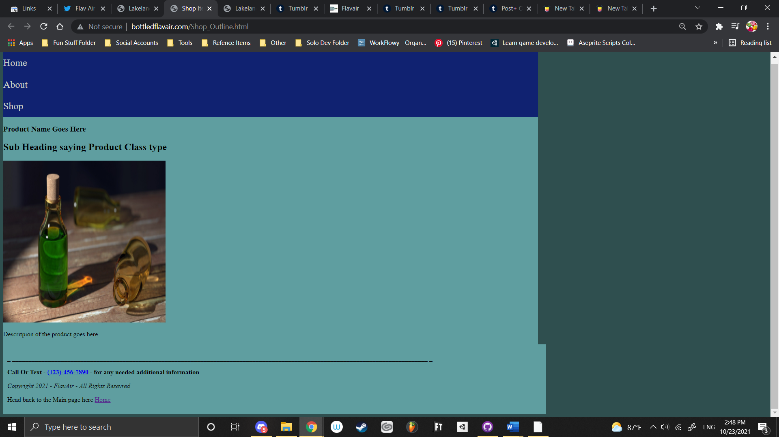

## Subscribe to our air memebership plan for only you today page

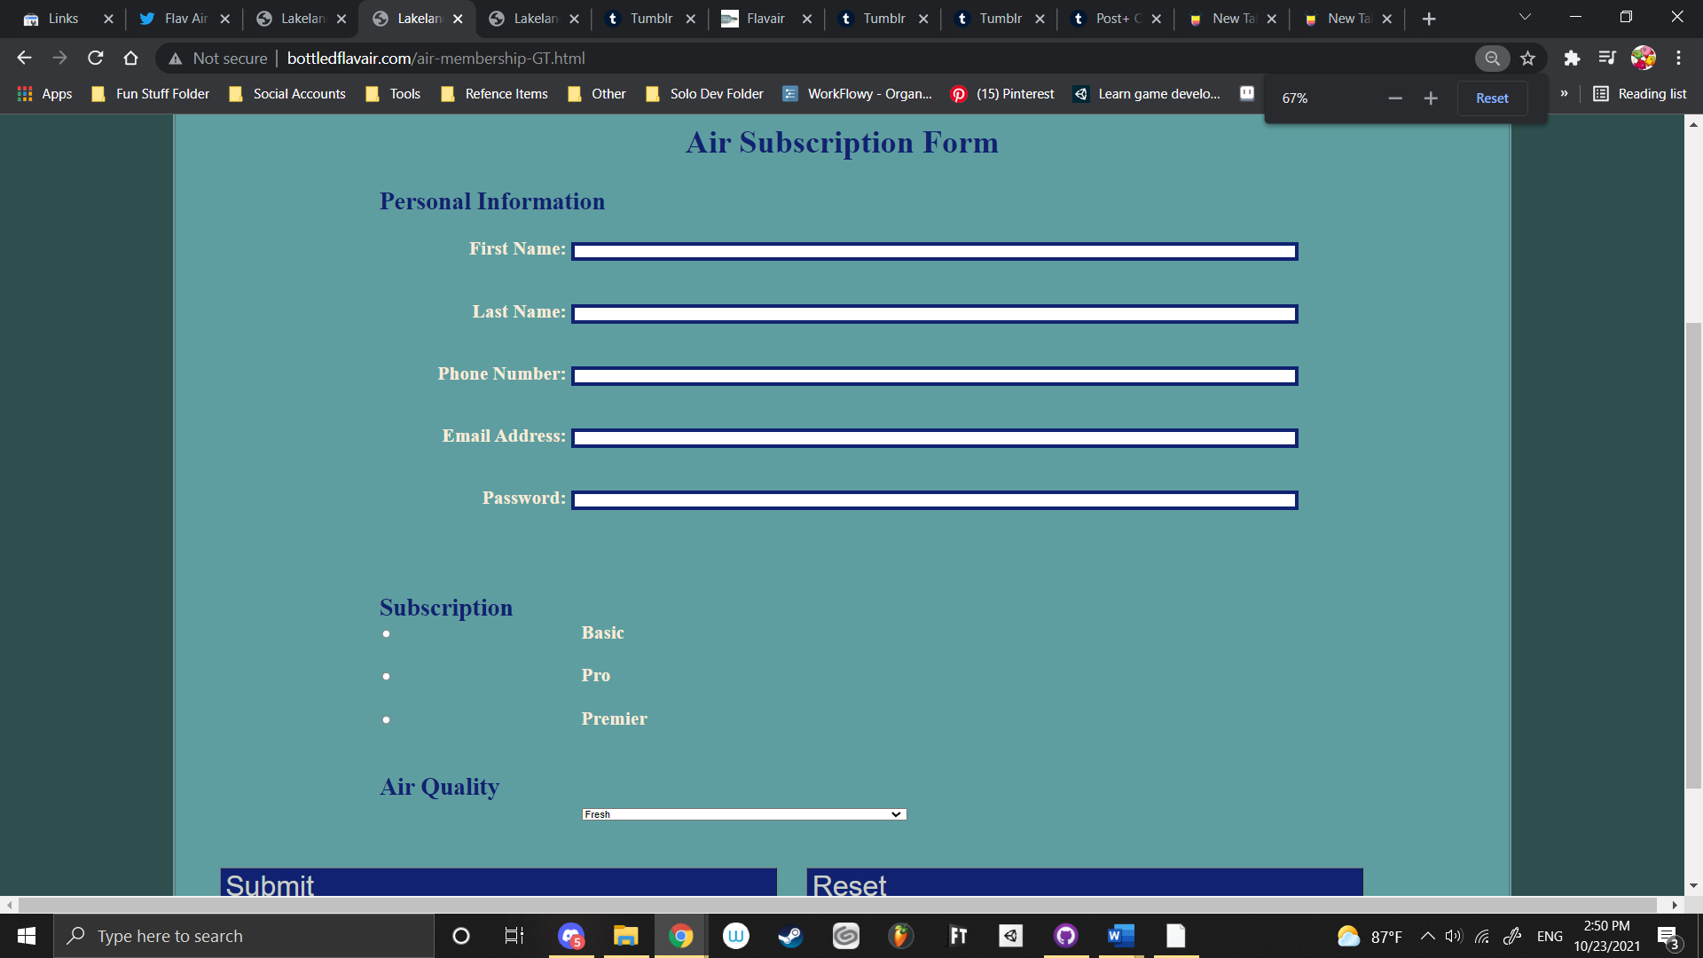

1. Open Google Search Console, select Links on the Left. Review the quantity of External Links, Internal Links, and Top Linking sites. If it is zero, then you need to increase the count. Provide a screenshot of your link count in Word/PDF document. 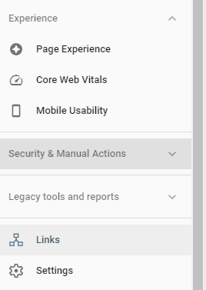 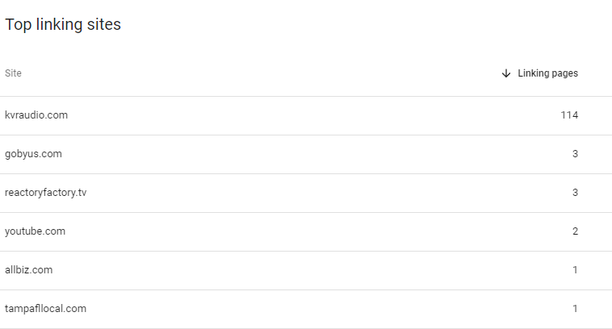

# Screenshots of Google Search Console

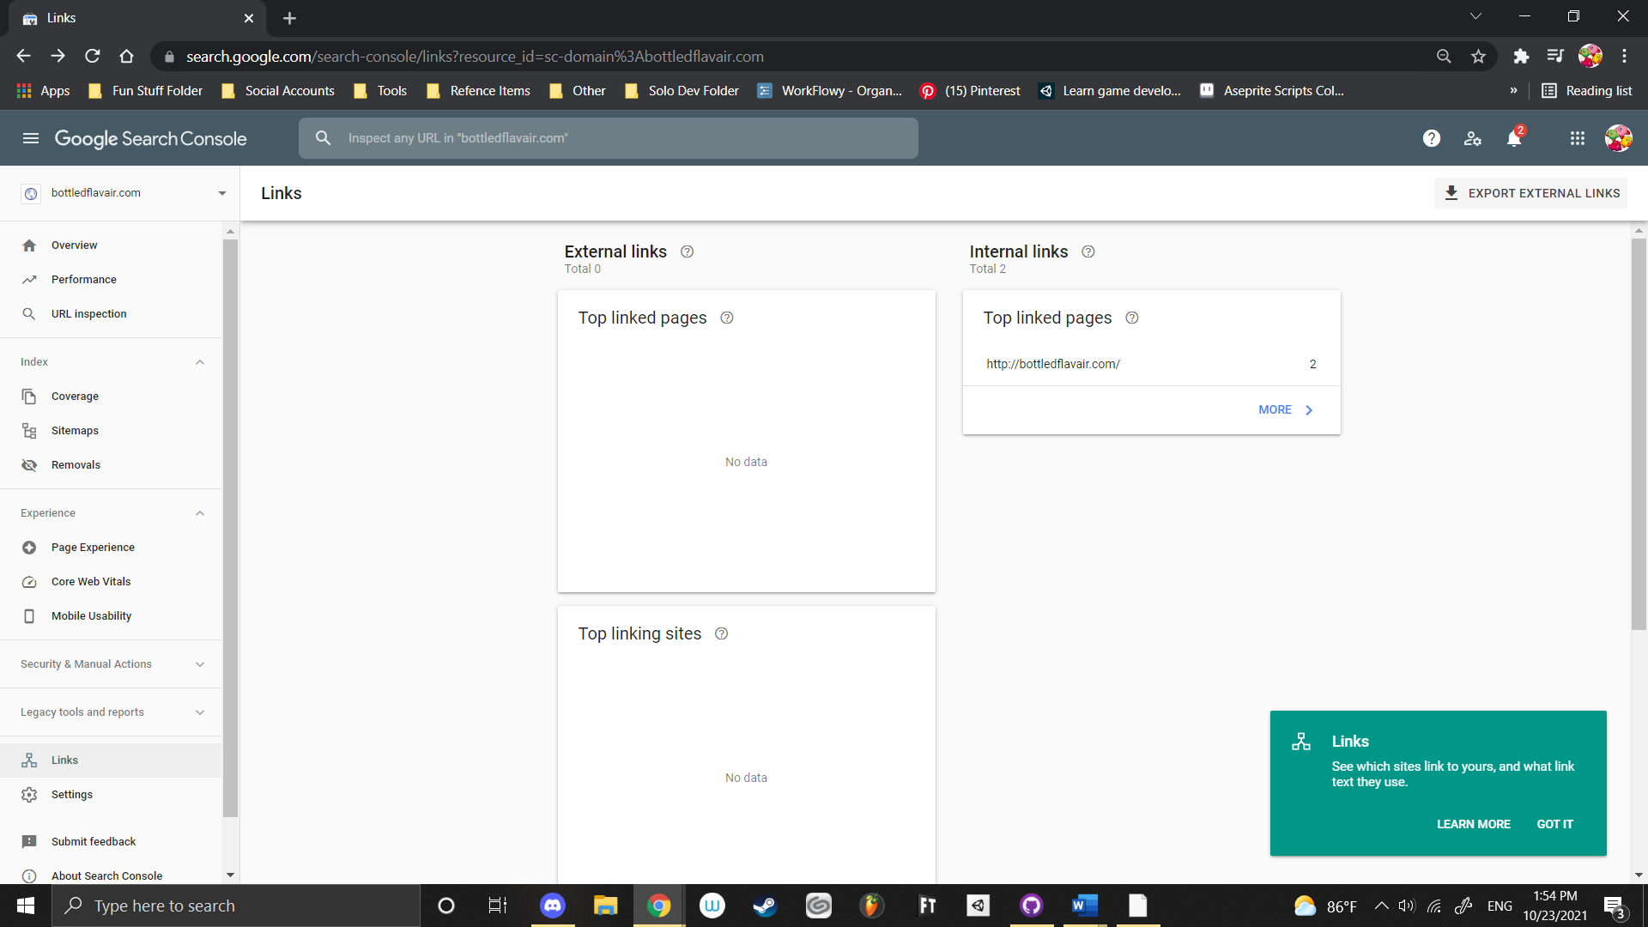

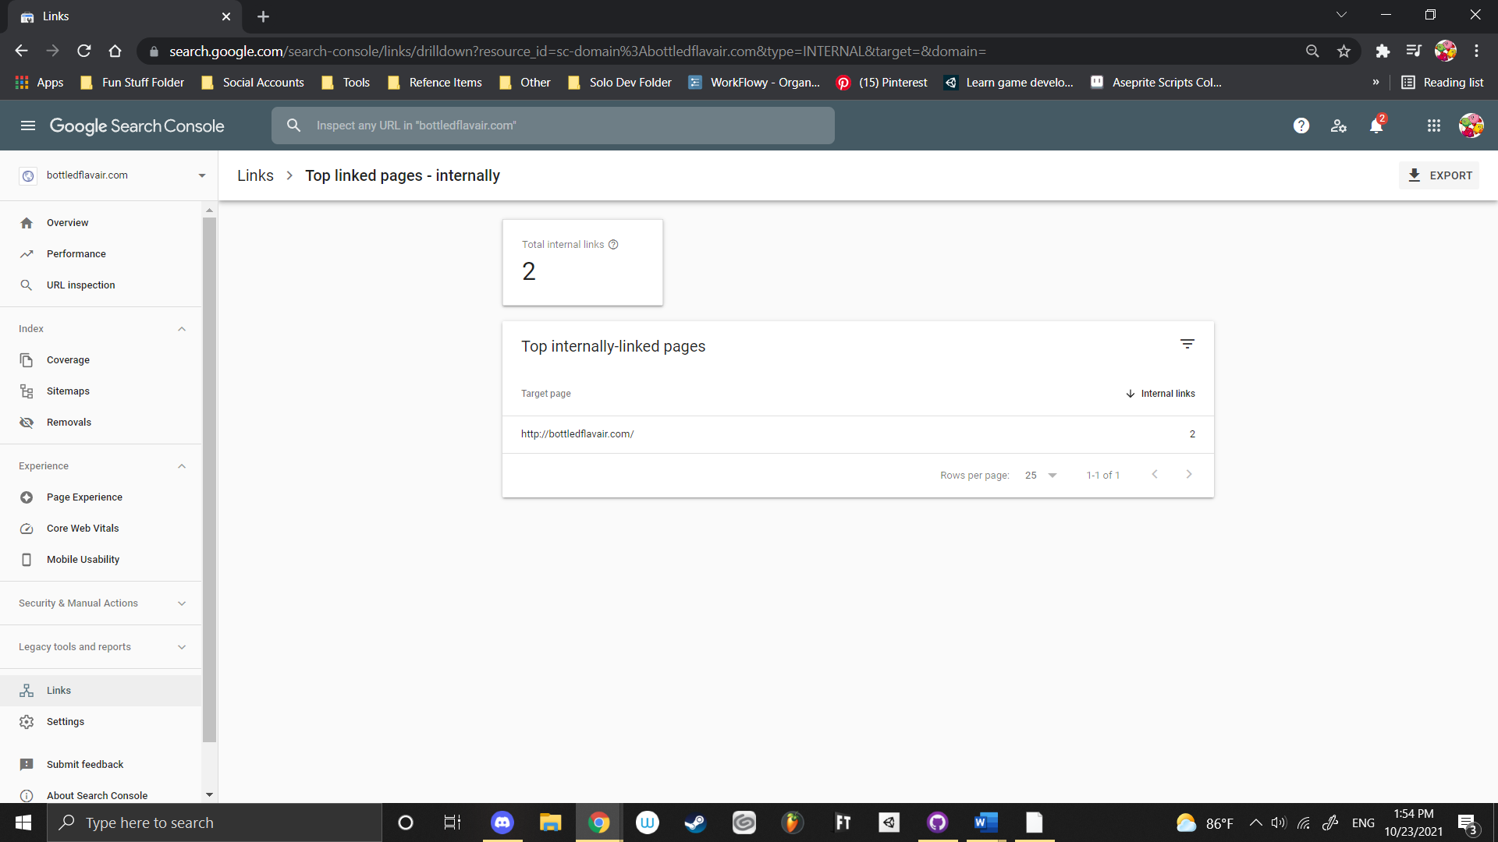

1. Create social media accounts that represents your Top Rank SEO website. Use a social media site that allows you to specify a webpage in your profile. Be sure to generate content on the site that reference your domain name as well as additional on going content. If you create a youtube account then create a video and add your back link (ie <http://somesite.com> or <http://somesite.com/about-us.html>). Add a screenshot of your social media’s profile back link. Adding the link to the profile is more effective than including the link in a comment.

# Social Media Link - Twitter

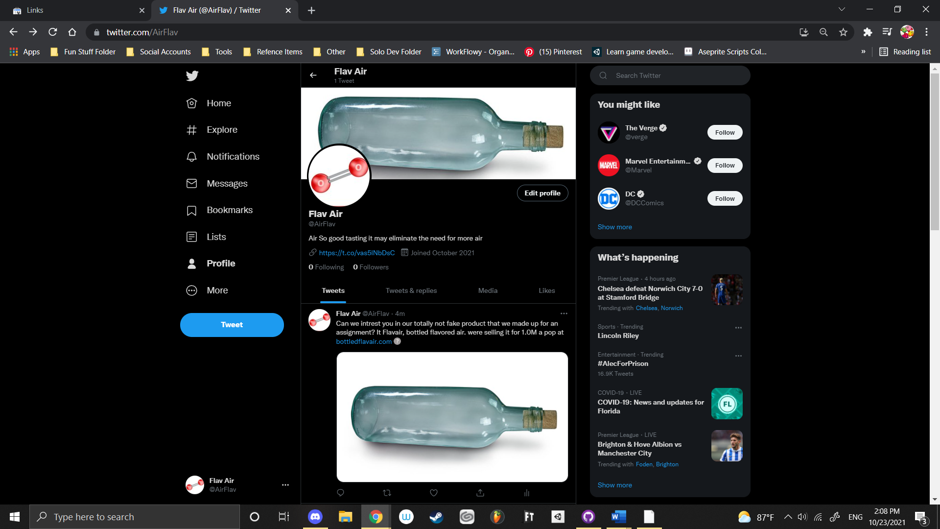

1. Create at least 1 (greater numbers are more effective) back link to your website from a different domain such as a web 2.0 site. (See list of Web 2.0 sites at <https://www.begindot.com/high-da-web-2-0-sites-for-backlinks/> ) In other words, if your site is newair.com, get a link from someplaceelse.com. An effective link is not set to “nofollow”. A back link should be coded as <a href="http://yourcoolsite.com">link text with keyword</a> The part “link text with keyword” is what is actually displayed on a site. Pick a site for the backlink that has a domain rank (DR) higher than your own site. Refer to <https://ahrefs.com/backlink-checker> Show a screenshot on word or pdf document.
2. Table

   Description automatically generated

# Backlink From higher Level DR - Tumblr

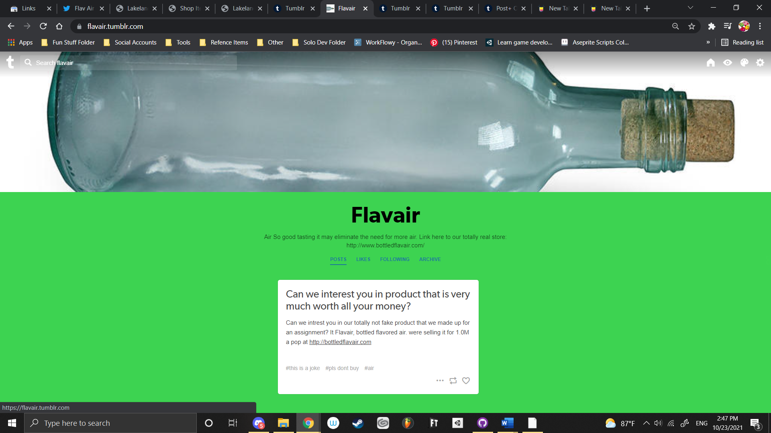

# Sitemap Screenshot

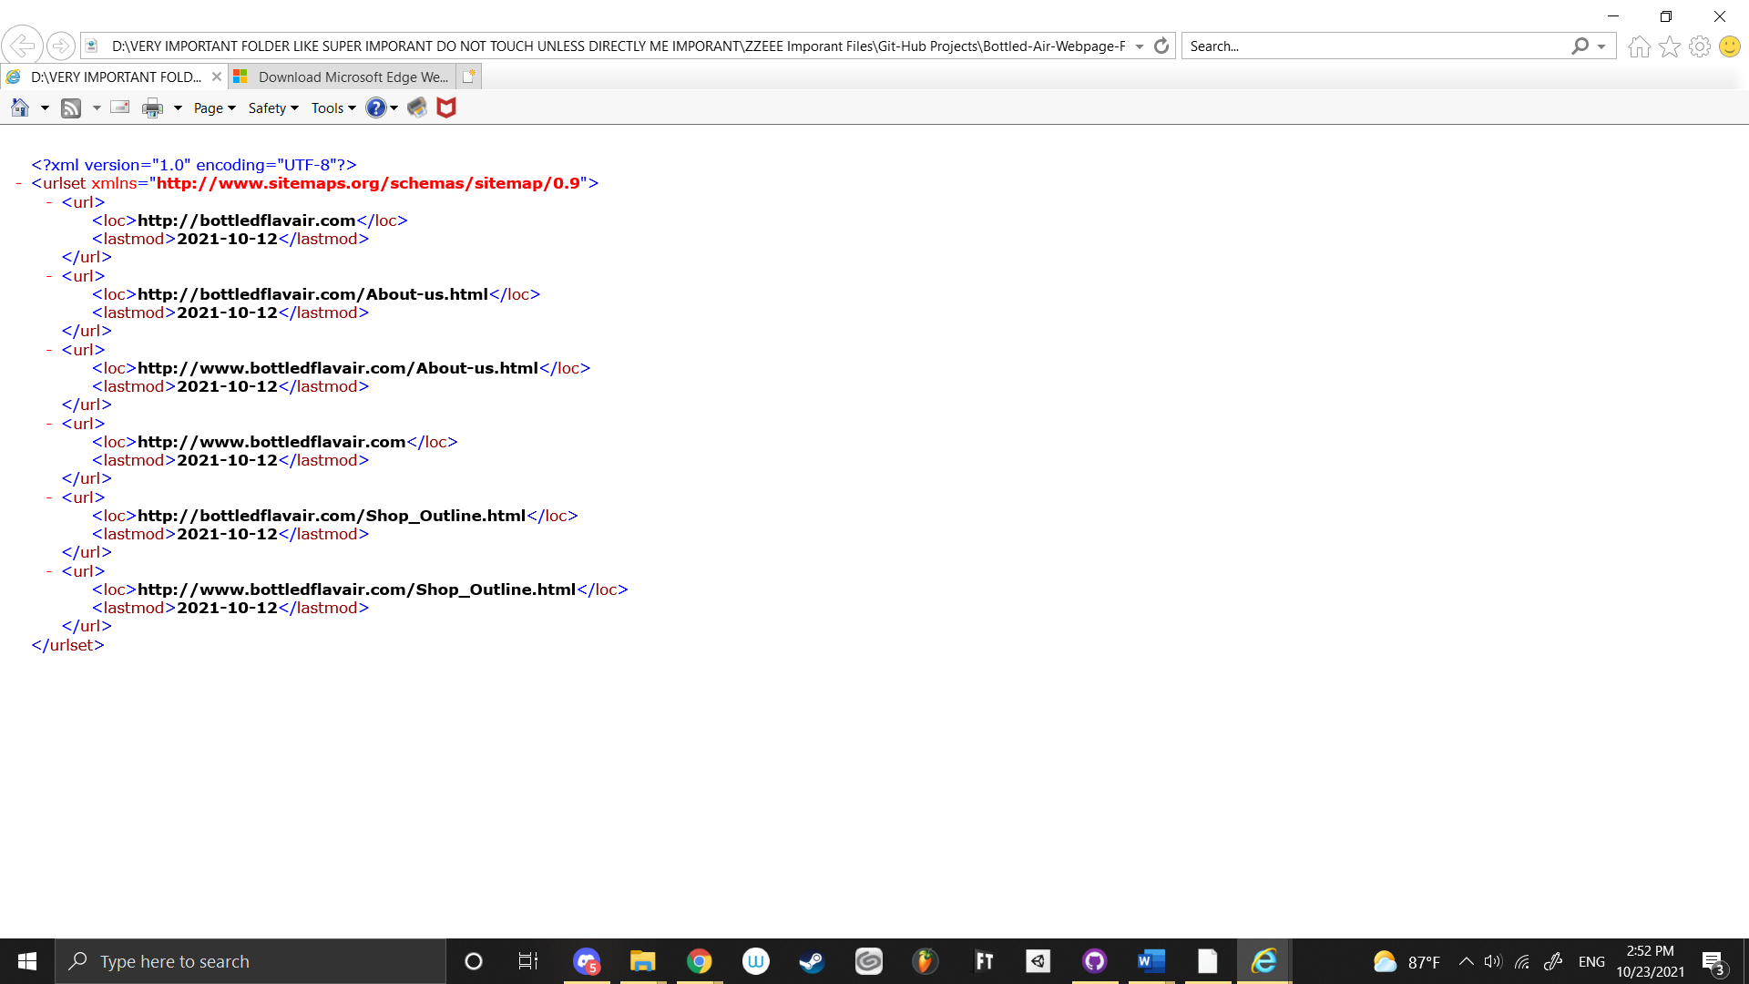

|  |  |
| --- | --- |
| **L12 HW - Web Form JS Validation Rubric** |  |
| **Assessment** | **Points** |
| Submit screenshot of new web page, internal links with <a> elements | 15 |
| Submit screenshot new Google Search Console Links | 15 |
| Submit screenshot of newly created social media profile back link | 15 |
| Submit screenshot of back link from another domain with higher DR | 15 |
| Add new web page(s) to sitemap. Provide screenshot of sitemap. | 15 |
| Appearance: Additional web page fits style of website and is properly linked to landing page. Keywords should be present. | 25 |
| Request Google Search Console crawl your website and additional pages. |  |
|  |  |
|  |  |
|  |  |
| Sub total | 100 |
| Extra Credit – Create a youtube video about Bottled Air and post to web site with proper back links in the comments. | 5 |